Readers, I can’t stress this enough!

Before you do anything in this document, you should perform a BACKUP of you Mac of any and all critical data that you may need.

With the announcement of Mac OS X “High Sierra” 10.13.0, many people ask me, Calvin. Should I upgrade? What’s the best way to upgrade? I usually ask these questions.

- Did you read what was all featured in the new O/S?
- Do you need those new features?
- Is your hardware up to spec for the new O/S?
- Will you have to upgrade the software (Apps) you use the most if you upgrade the O/S?
- Can you afford all of the costs associated with the upgrade? Hardware and Software upgrades?

Depending on how you answer those above questions will determine if you should upgrade. If you did not answer ”Yes” to them all, you probably are not ready for the upgrade.

If you can answer “Yes”, then you need to have all things in order.

- Fully understand the new features you feel you need.
- Confirmed that your Mac can operate to your satisfaction with the upgrade. Sometimes the upgrade will install and work but it may be slower than you want. It may need more memory, larger hard drive…. Therefore have all needed hardware components installed PRIOR to doing the upgrade.
- Make sure you have located all media, and license keys for software that you use and will reload on the upgraded Mac. Make sure that the software is compatible with the upgrade PRIOR to doing the upgrade. Remember some of the software you use may have been downloaded instead of shipped on DVD or CD.
- You are going to need an external hard drive that is at least the same size or larger than the internal drive in your Mac where the O/S and everything else resides. This hard drive is going to be wiped of all data on it so unless you have it partitioned and you select the appropriate partition, make sure that you do not need any thing on that drive. If you bought a new blank drive, then you are all set to format it as a Mac drive and move forwar. Make sure that the hard drive is the fastest you have or can afford. It need to be a drive that can be booted from externally ( Usually USB 3.0 or Thunderbolt ) Check your Mac for the bootable external hard drive it supports.

Okay, now that you have all things prepped and ready. Here is the methodology that I use. You can do it other ways I am aware but this is the way I prefer.

- Download from http://shirt-pocket.com a copy of the software called “Super Duper” You can use it forever for free but I strongly suggest supporting them and getting all the features of the software by purchasing the software for only $28.00 as of this writing and well worth it.

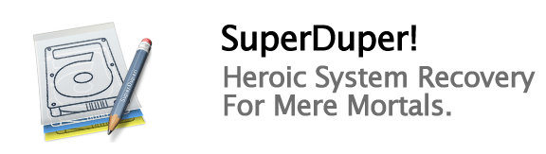

- Attach your external hard drive. It should be formatted for Mac file system with Disk Utility. Name this hard drive something like “Cal’s Sierra Upgrade”

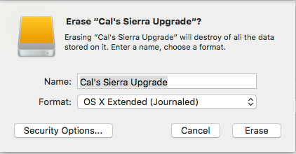

- Start “Super Duper” and Copy (Super Duper is really Cloning) your internal Mac hard drive to the Hard Drive named “Sierra Upgrade” It will vary in the amount of time it takes to run based on the amount of data and apps that are on the hard drive.

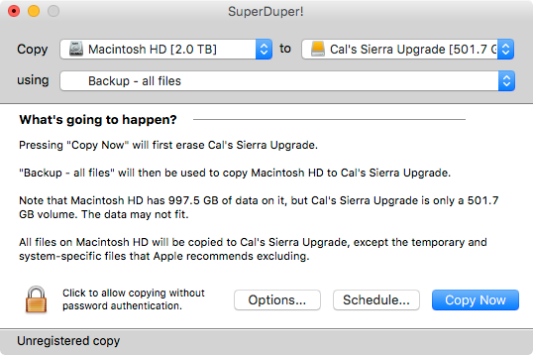

- After Super Duper completes it should be set to reboot the computer and restart the computer from the external hard drive. Once it boots and you can confirm that the Mac is running from the external hard drive, test some of your software to make sure it working properly. Best way to test if you are booted to the external hard drive is to try and drag the external hard drive into the trash. If you can successfully do it, you are not booted to the external. The Mac O/S will not allow you to trash the hard drive you are actively using.
- Now that you have confirmed that your external, bootable, cloned backup is working, you’ll want to apply the Mac O/S X 10.13.0 High Sierra upgrade against the external hard drive NOT the internal.
- After the external hard drive has been upgraded to High Sierra, upgrade and software if needed.
- Make a folder on the desktop called “During Upgrade”. If you create and thing using your applications that you want to keep, save them in this folder.
- Run you Mac booted to the external upgraded High Sierra hard drive as long as you think it is needed or until you are comfortable with the upgrade. Take your time and make sure everything you need to do with your Mac is working under High Sierra.
- Here is the real beauty of doing the upgrade this way. If you boot to the external that you upgraded to High Sierra and you find that there are problems with the upgrade. You simply just disconnect the external drive and reboot your Mac. Instantly you are back to the point you were at BEFORE you did the upgrade and you are unscathed. Woo Hoo!

- When you have tested all your needed applications and every thing is working to your satisfaction then you can apply the upgrade to your internal hard drive of your Mac by;
  - Powering down your Mac.
  - Disconnecting the external hard drive.
  - Powering up your Mac the normal way.
  - Apply the High Sierra upgrade
  - Update and or apply any patches to your software applications
  - Check out all your application software ( it should perform the same as the external drive
  - Attach the external drive and copy the “During Upgrade” folder contents to the appropriate locations on the internal hard drive.

Welcome to the High Sierra

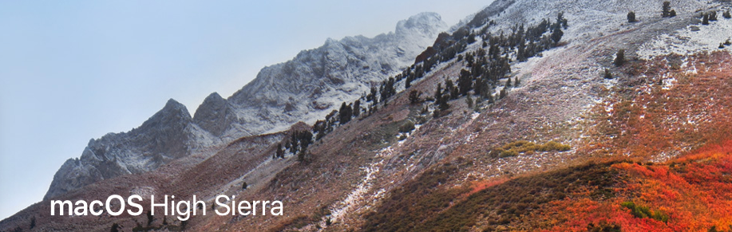
Happy Mac’ing!

